
Faculty of Science

Course: CSCI 2020u – Software System Development & Integration
Component: Assignment
Weight: 10%
Deadline: March 5, 2020 (due by 11:59pm)

Collaboration Policy
You are permitted to work on this assignment in a team, and submit the results as a team. For this sort of assignment, with an open-ended component, the collaboration between multiple team members can be beneficial. Between groups, however, please limit the discussion to the level of general strategy (not code). Groups of size 2 are recommended. Larger groups will be considered with the proviso that the marker will mark your assignment with higher expectations. In any case, be sure that all members of the team fully understand all code, otherwise they will miss intended learning objectives, which may be a considerable disadvantage at exam time.

How to Submit
You will maintain a git repository for this assignment, which is a public repository. To submit the assignment, create a single file ‘README.txt’ that contains instructions on how to download, compile, and run your codes for each question. A .zip, .7z, or .rar file will not be acceptable. Also submit this word file (once you complete) into related drop box on Blackboard before deadline.

Note: Comments are mandatory. Failure to properly document your program will result in a deduction on the marks you receive for this (and any other) assignment.

Remember:
You need to complete this file and submit it in related drop box on Blackboard, in addition to uploading your codes in your git repository, before deadline.

Question 1: Displaying Three Cards

Problem Description:
Display a frame that contains three labels. Each label displays a card, as shown in the figure below. The card image files are named 1.png, 2.png, ..., 54.png and stored in the image/card directory. All three cards are distinct and selected randomly.

The image icons can be found in the attached card folder.

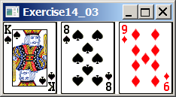

Your Task:
- Create three ImageView and set their icons using the images.
- Display three images from 54 image cards randomly.

Your Code:
Copy-paste your code here:

//Obaida Issa 100702054
//CSCI 2020U
package sample;
import java.awt.*;
import javax.swing.*;
public class Cards extends JFrame
{
//constructor of the class
public Cards()
{
//declaring layout of grid
setLayout(new GridLayout(1,3,5,5));
//declaration of imageicon array
ImageIcon []icon=new ImageIcon[52];
for(int i=1; i<52 ; i++)
{
//pathway to the png images on my computer
icon[i]= new ImageIcon("C:\\Users\\obaid\\IdeaProjects\\question_1\\src\\sample"+(i)+".png");
}
//random number generation
int r=(int)(Math.random()*52);
int q=(int)(Math.random()*52);
int p=(int)(Math.random()*52);
//adding the random image to JLabel
add(new JLabel(icon[r]));
add(new JLabel(icon[q]));
add(new JLabel(icon[p]));
}
//main method
public static void main(String args[])
{
Cards cards = new Cards();
//frame title
cards.setTitle("Question 1");
//frame size
cards.setSize(300,200);
//exit frame on close
cards.setDefaultCloseOperation (JFrame.EXIT_ON_CLOSE);
//set the visibility of frame
cards.setVisible(true);
}
}

package sample;
public class Controller {
}

<?import javafx.geometry.Insets?>
<?import javafx.scene.layout.GridPane?>
<?import javafx.scene.control.Button?>
<?import javafx.scene.control.Label?>
<GridPane fx:controller="sample.Controller"
xmlns:fx="http://javafx.com/fxml" alignment="center" hgap="10" vgap="10">
</GridPane>

Screen shots:
Include two screen shots here:

I was not able to get the mapping to the images to work properly.

Question 2: Investment-Value calculator

Problem Description:
Write a program that calculates the future value of an investment at a given interest rate for a specified number of years. The formula for the calculation is as follows:

futureValue = investmentAmount * (1 + monthlyInterestRate)years*12

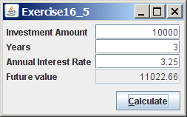

Your Task:
Use text fields for interest rate, investment amount, and years. Display the future amount in a text field when the user clicks the Calculate button, as shown in the figure.

Your Code:
Copy-paste your code here.

//Obaida Issa 100702054
//CSCI2020U
package sample;
import javafx.application.Application;
import javafx.geometry.Insets;
import javafx.geometry.Pos;
import javafx.scene.Scene;
import javafx.scene.control.Button;
import javafx.scene.control.Label;
import javafx.scene.control.TextField;
import javafx.scene.layout.GridPane;
import javafx.scene.layout.HBox;
import javafx.stage.Stage;
public class Main extends Application {
@Override
public void start(Stage primaryStage) throws Exception {
LoanInvestCalculator calcPane = new LoanInvestCalculator();
primaryStage.setScene(new Scene(calcPane, calcPane.getPrefWidth(), calcPane.getPrefHeight()));
primaryStage.setTitle("Question 2");//Title of the calculator
primaryStage.show();
}
public static void main(String[] args) {
Application.launch(args);//launch the calculator
}
private class LoanInvestCalculator extends GridPane {
Label amountLabel = new Label("Investment Amount:");//first label
TextField amountText = new TextField();
Label yearsLabel = new Label("Years:");//second label
TextField yearsText = new TextField();
Label rateLabel = new Label("Annual Interest Rate:");//third label
TextField rateText = new TextField();
Label futureValueLabel = new Label("Future Value:");//fourth label
TextField futureValueText = new TextField();
Button btCalc = new Button("Calculate");//Calculate button
private LoanInvestCalculator() {
setPadding(new Insets(10, 10, 10, 10));
setAlignment(Pos.CENTER);
setHgap(10);
setVgap(10);
//columns and rows declaration
add(amountLabel, 0, 0);
add(amountText, 1, 0);
add(yearsLabel, 0, 1);
add(yearsText, 1, 1);
add(rateLabel, 0, 2);
add(rateText, 1, 2);
add(futureValueLabel, 0, 3);
add(futureValueText, 1, 3);
HBox buttons = new HBox();
buttons.getChildren().add(btCalc);
buttons.setAlignment(Pos.BOTTOM_RIGHT);//position of the button
add(buttons, 1, 4);
btCalc.setOnAction(e-> calcFutureValue());
// Editing TextField settings
TextField[] textFields = (TextField[])getArray(
amountText, yearsText, rateText, futureValueText);//array of textfields
for (TextField tf : textFields) {
tf.setAlignment(Pos.BASELINE_RIGHT);
}
futureValueText.setDisable(true);
}
private Object[] getArray(Object... objects) {
Object[] temp = new TextField[objects.length];
for (int i = 0; i < objects.length; i++) {
temp[i] = objects[i];
}
return temp;
}
public void calcFutureValue() {
double investmentAmount = Double.parseDouble(amountText.getText());
double years = Double.parseDouble(yearsText.getText());
double monthInterestRate = Double.parseDouble(rateText.getText()) / 12 / 100;
double futureValue = investmentAmount * Math.pow(1 + monthInterestRate, years * 12);
futureValueText.setText(String.format("$%.2f", futureValue));//set text to calculated value
}
}
}

package sample;
public class Controller {
}

<?import javafx.geometry.Insets?>
<?import javafx.scene.layout.GridPane?>
<?import javafx.scene.control.Button?>
<?import javafx.scene.control.Label?>
<GridPane fx:controller="sample.Controller"
xmlns:fx="http://javafx.com/fxml" alignment="center" hgap="10" vgap="10">
</GridPane>

Screen shots:
Include two screen shots here:

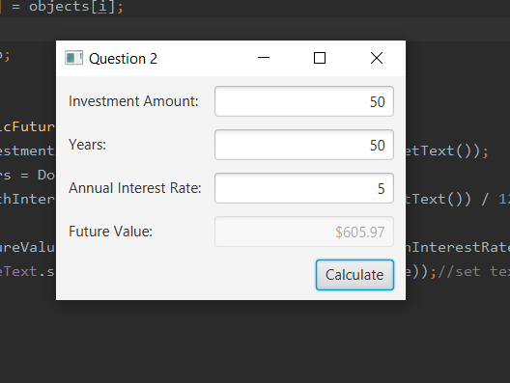

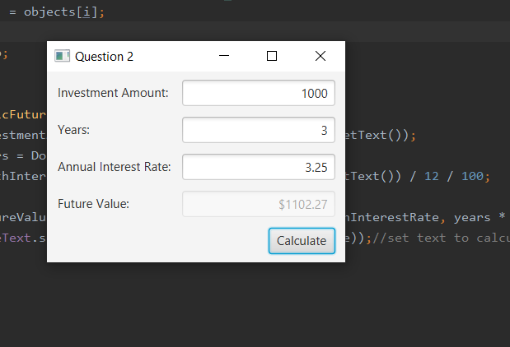
Question 3: Dragging Points on a Circle

Problem Description:
Draw a circle with three random points on the circle. Connect the points to form a triangle. Display the angles in the triangle. Use the mouse to drag a point along the perimeter of the circle. As you drag it, the triangle and angles are redisplayed dynamically.

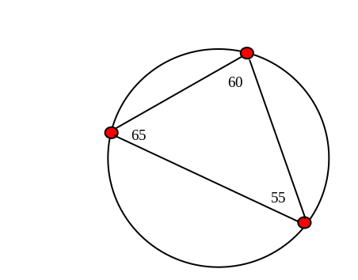

Here is the formula to compute angles:

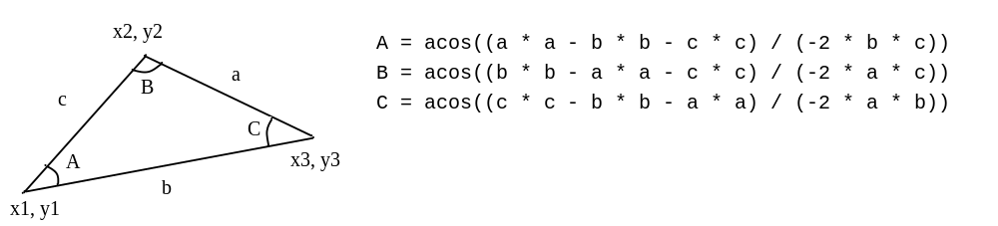

Your Code:
Copy-paste your code here:

//Obaida Issa 100702054
//CSCI2020U
package sample;
import javafx.scene.layout.BorderPane;
import javafx.scene.layout.Pane;
import javafx.scene.paint.Color;
import javafx.scene.shape.Circle;
import javafx.scene.shape.Line;
import javafx.scene.text.Font;
import javafx.scene.text.Text;
import javafx.scene.text.TextAlignment;
import javafx.stage.Stage;
import javafx.application.Application;
import javafx.beans.property.DoubleProperty;
import javafx.beans.value.ChangeListener;
import javafx.beans.value.ObservableValue;
import javafx.event.EventHandler;
import javafx.geometry.Insets;
import javafx.geometry.Pos;
import javafx.scene.Scene;
import javafx.scene.control.Label;
import javafx.scene.input.MouseEvent;
public class Main extends Application {
@Override
public void start(Stage primaryStage) {
final PointPane pane = new PointPane(640, 480);
pane.setStyle("-fx-background-color: wheat;");
Label label = new Label("Click and drag the points.");
BorderPane borderPane = new BorderPane(pane);
BorderPane.setAlignment(label, Pos.CENTER);
label.setPadding(new Insets(5));
borderPane.setBottom(label);
Scene scene = new Scene(borderPane);
primaryStage.setTitle("Question 3");
primaryStage.setScene(scene);
primaryStage.show();
}
private class PointPane extends Pane {
final Circle circle = new Circle();
final Vertex[] v = new Vertex[3];
final int strokeWidth = 2;
final Color circleStroke = Color.GRAY, legStroke = Color.BLACK;
@SuppressWarnings("SameParameterValue")
PointPane(double w, double h) {
this.setPrefSize(w, h);
this.setWidth(w);
this.setHeight(h);
circle.setStroke(circleStroke);
circle.setFill(Color.TRANSPARENT);
circle.setStrokeWidth(strokeWidth);
circle.radiusProperty().bind(this.heightProperty().multiply(0.4));
circle.centerXProperty().bind(this.widthProperty().divide(2));
circle.centerYProperty().bind(this.heightProperty().divide(2));
this.getChildren().add(circle);
// create the vertices at random angles
for (int i = 0; i < v.length; i++) {
v[i] = new Vertex(circle, 2 * Math.PI / v.length * (i + Math.random()));
v[i].radiusProperty().bind(circle.radiusProperty().divide(10));
v[i].setPosition();
v[i].setStroke(new Color(i == 0 ? 1 : 0, i == 1 ? 1 : 0, i == 2 ? 1 : 0, 1));
v[i].setFill(Color.TRANSPARENT);
v[i].setStrokeWidth(strokeWidth);
this.getChildren().add(v[i]);
v[i].setOnMouseDragged(new EventHandler<MouseEvent>() {
@Override
public void handle(MouseEvent event) {
int i;
for (i = 0; i < v.length; i++)
if (v[i] == event.getSource())
break;
v[i].setAngle(event.getX(), event.getY());
moveUpdate((Vertex) event.getSource());
}
});
}
// create the legs and bind their endpoints to their corresponding vertices
for (int i = 0; i < v.length; i++) {
int j = i + 1 < v.length ? i + 1 : 0;
int k = j + 1 < v.length ? j + 1 : 0;
v[i].bindLeg(v[j], v[k]);
v[i].leg.setStroke(legStroke);
v[i].leg.setStrokeWidth(strokeWidth);
this.getChildren().add(v[i].leg);
// create the text nodes and bind their locations to their corresponding vertices
this.getChildren().add(v[i].text);
}
for(DoubleProperty p: new DoubleProperty[]
{circle.radiusProperty(), circle.centerXProperty(), circle.centerYProperty()})
p.addListener(new ResizeListener());
moveUpdate(v[0]);
}
void moveUpdate(Vertex vert) {
vert.setPosition();
double[] legLength = new double[3];
for (int i = 0; i < v.length; i++)
legLength[i] = v[i].getLegLength();
for (int i = 0; i < v.length; i++) {
int j = i + 1 < v.length ? i + 1 : 0;
int k = j + 1 < v.length ? j + 1 : 0;
double a = legLength[i], b = legLength[j], c = legLength[k];
double d = Math.toDegrees(Math.acos((a * a - b * b - c * c) / (-2 * b * c)));
v[i].setText(d);
}
}
private class ResizeListener implements ChangeListener<Number> {
@Override
public void changed(ObservableValue<? extends Number> observableValue, Number oldWidth, Number newWidth) {
for (Vertex aV : v) {
aV.setPosition();
}
}
}
}
private class Vertex extends Circle {
final Circle circle;
final Line leg;
final Text text;
double centerAngle;
//circle declaration
Vertex(Circle circle, double centerAngle) {
this.circle = circle;
this.setAngle(centerAngle);
this.leg = new Line();
this.text = new Text();
this.text.setFont(Font.font(20));
this.text.setStroke(Color.BLACK);
this.text.setTextAlignment(TextAlignment.CENTER);
this.text.xProperty().bind(this.centerXProperty().add(25));
this.text.yProperty().bind(this.centerYProperty().subtract(10));
}
double getCenterAngle() {return this.centerAngle;}
void setPosition() {
this.setCenterX(circle.getCenterX() + circle.getRadius() * Math.cos(this.getCenterAngle()));
this.setCenterY(circle.getCenterY() + circle.getRadius() * Math.sin(this.getCenterAngle()));
}
void setAngle(double centerAngle) {
this.centerAngle = centerAngle;
}
void setAngle(double x, double y) {
this.setAngle(Math.atan2(y - circle.getCenterY(), x - circle.getCenterX()));
}
void bindLeg(Vertex v1, Vertex v2) {
leg.startXProperty().bind(v1.centerXProperty());
leg.startYProperty().bind(v1.centerYProperty());
leg.endXProperty().bind(v2.centerXProperty());
leg.endYProperty().bind(v2.centerYProperty());
}
double getLegLength() {
return Math.sqrt(Math.pow(leg.getStartX()-leg.getEndX(),2) + Math.pow(leg.getStartY()-leg.getEndY(),2));
}
void setText(double angle) {
this.text.setText(String.format("%.0f\u00B0", angle));
}
}
}

package sample;
public class Controller {
}

<?import javafx.geometry.Insets?>
<?import javafx.scene.layout.GridPane?>
<?import javafx.scene.control.Button?>
<?import javafx.scene.control.Label?>
<GridPane fx:controller="sample.Controller"
xmlns:fx="http://javafx.com/fxml" alignment="center" hgap="10" vgap="10">
</GridPane>

Screen shots:
Include two screen shots here:
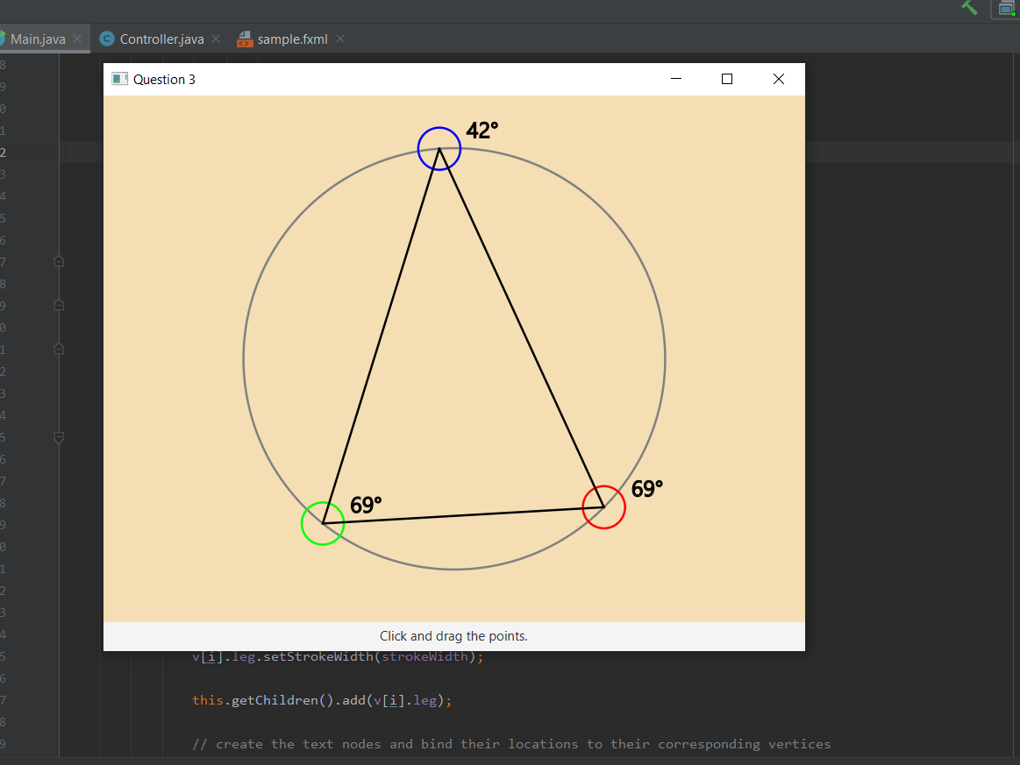

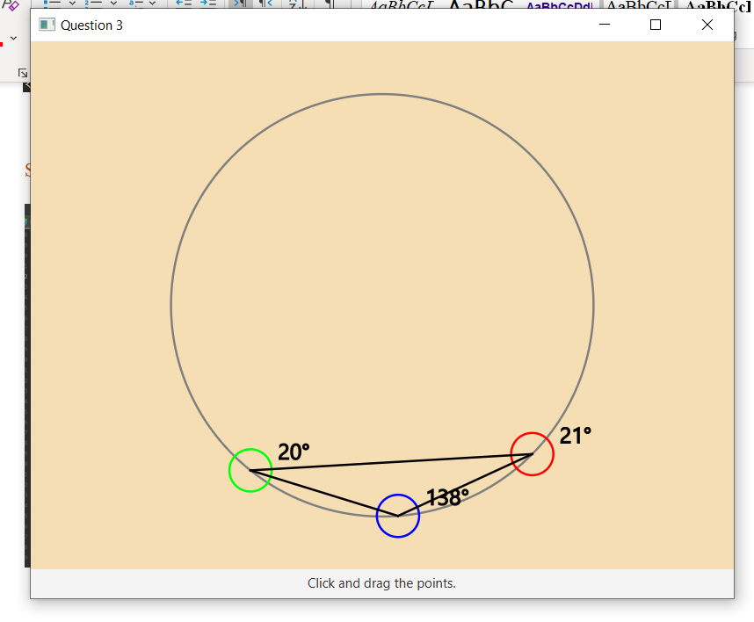
Question 4: Histogram

Problem Description:
Develop a program that displays a histogram to show the occurrences of each letter in a text area. The histogram should show the occurrences of each letter in a text file, as shown in the following figure. Assume that the letters are not case sensitive.

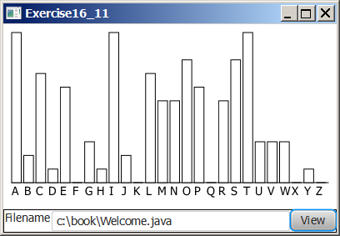

Your Task:
- Place a pane that will display the histogram in the center of the frame.
- Place a label and a text field in a panel, and put the panel in the south side of the frame. The text file will be entered from this text field.
- Pressing the Enter key on the text field causes the program to count the occurrences of each letter and display the count in a histogram.

Your Code:
Copy-paste your code here:

//Obaida Issa 100702054
//CSCI2020U
package sample;
import hist.Histogram;
import javafx.application.Application;
import javafx.scene.Scene;
import javafx.scene.control.Button;
import javafx.scene.control.ContentDisplay;
import javafx.scene.control.Label;
import javafx.scene.control.TextField;
import javafx.scene.layout.HBox;
import javafx.scene.layout.Pane;
import javafx.scene.layout.VBox;
import javafx.stage.Stage;
public class Main extends Application {
Pane pane = new Pane();
TextField textField = new TextField();
VBox box = new VBox();
@Override
//declaration of main window
public void start(Stage primaryStage) throws Exception {
Label lblFilename = new Label("Filename:", textField);
lblFilename.setContentDisplay(ContentDisplay.RIGHT);
textField.setPrefColumnCount(20);
Button btView = new Button("View");
HBox hBox = new HBox(lblFilename, btView);
box.getChildren().addAll(pane, hBox);
Scene scene = new Scene(box);
primaryStage.setScene(scene);
btView.setOnAction(e-> {
update();
box.setTranslateY(10);
primaryStage.sizeToScene();
});
primaryStage.show();
}
private void update() {
Histogram graph = new Histogram(textField.getText());
pane.getChildren().add(graph);
}
public static void main(String[] args) {
Application.launch(args);
}
}

//Obaida Issa 100702054
//main package for histogram class
package hist;
import javafx.geometry.VPos;
import javafx.scene.control.ContentDisplay;
import javafx.scene.control.Label;
import javafx.scene.layout.GridPane;
import javafx.scene.layout.Pane;
import javafx.scene.shape.Rectangle;
import java.io.File;
import java.io.IOException;
import java.util.Scanner;
public class Histogram extends Pane {
private char[] chars = new char[26];
private int counts[] = new int[26];
private Rectangle[] bars = new Rectangle[26];
private File file;
GridPane pane;
double w = 350;
double h = 350;
public Histogram(String filename) {
this.file = new File(filename.trim());
setWidth(w);
setHeight(h);
readFile();
draw();
}
private void readFile() {
Scanner scanner;
String s = "";
try {
scanner = new Scanner(file);
while (scanner.hasNextLine()) {
s += scanner.nextLine();
}
} catch (IOException ex) {
}
s = s.toUpperCase();
for (int i = 0; i < s.length(); i++) {
char character = s.charAt(i);
if (Character.isLetter(character)) {
counts[character - 'A']++;
}
}
}
private double getTotal() {
double total = 0;
for (int count : counts) {
total += count;
}
return total;
}
private void draw() {
pane = new GridPane();
double barW = w / chars.length;
double total = getTotal();
for (int i = 0; i < counts.length; i++) {
chars[i] = (char) ('A' + i);
double percentage = counts[i] / total;
double barH = h * percentage;
bars[i] = new Rectangle(barW, barH);
Label label = new Label(chars[i] + "", bars[i]);
label.setContentDisplay(ContentDisplay.TOP);
pane.add(label, i, 0);
GridPane.setValignment(label, VPos.BASELINE);
}
getChildren().addAll(pane);
}
public int[] getCounts() {
return counts;
}
public void setCounts(int[] counts) {
this.counts = counts;
draw();
}
}

package sample;
public class Controller {
}

<?import javafx.geometry.Insets?>
<?import javafx.scene.layout.GridPane?>
<?import javafx.scene.control.Button?>
<?import javafx.scene.control.Label?>
<GridPane fx:controller="sample.Controller"
xmlns:fx="http://javafx.com/fxml" alignment="center" hgap="10" vgap="10">
</GridPane>

Screen shots:
Include two screen shots here:
I was not able to get this code to read from the file.

Remember:

You need to complete this file and submit it in related drop box on Blackboard, in addition to uploading your codes in your git repository, before deadline.

